Line–Circle Tangency

Definition
# Source: AI Source: Provided by: [Data Path: Persons Table -> ID Column: 1, Name_En Column: Motasem Essam] -> From: [ChatGPT] on [7/25/2026]
Line–Circle Tangency is the relationship in which a line touches a circle at exactly one point.
That single common point is called the Tangency Point or Point of Tangency.
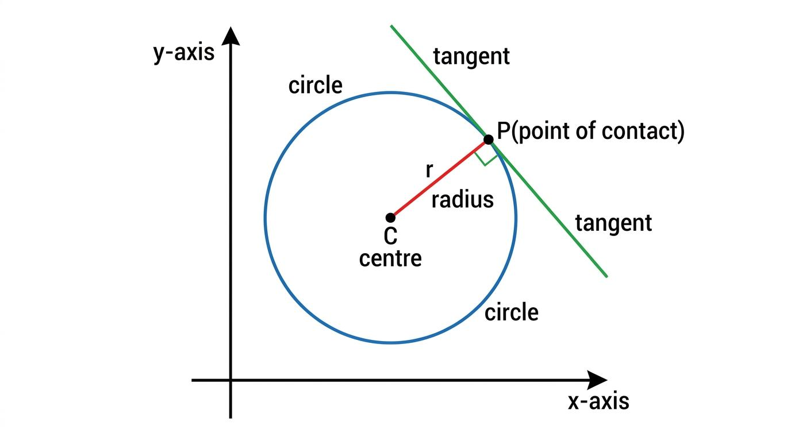
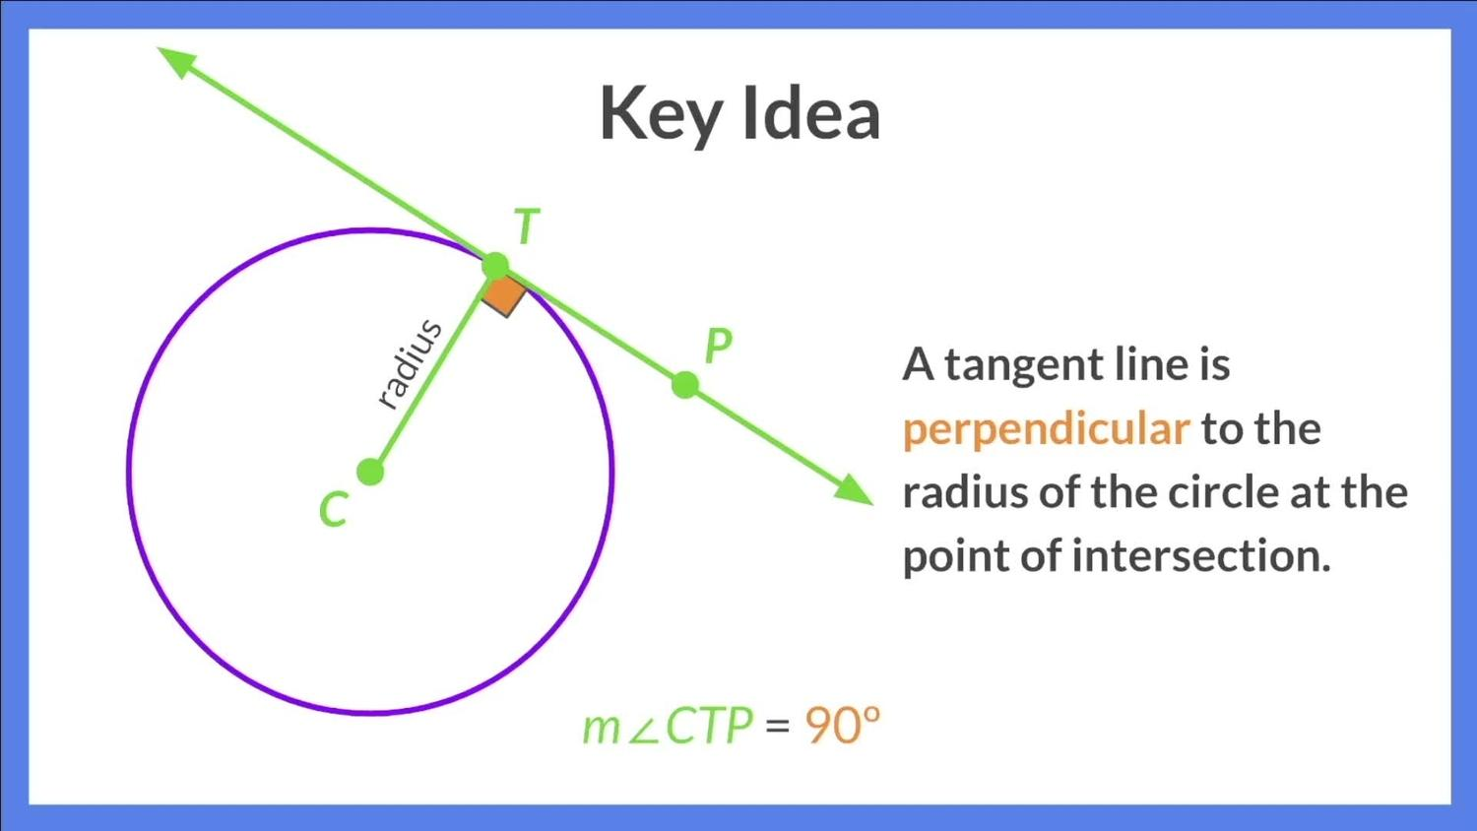
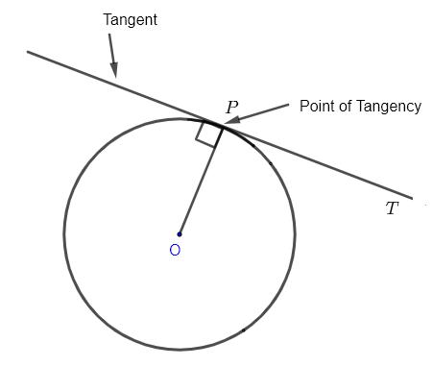
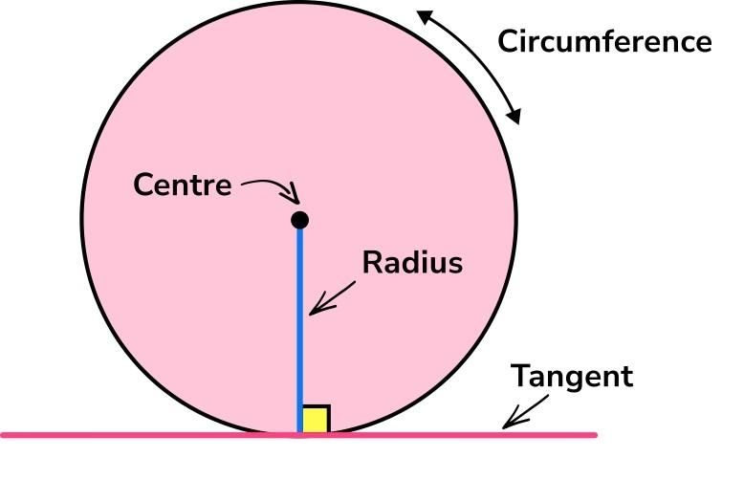
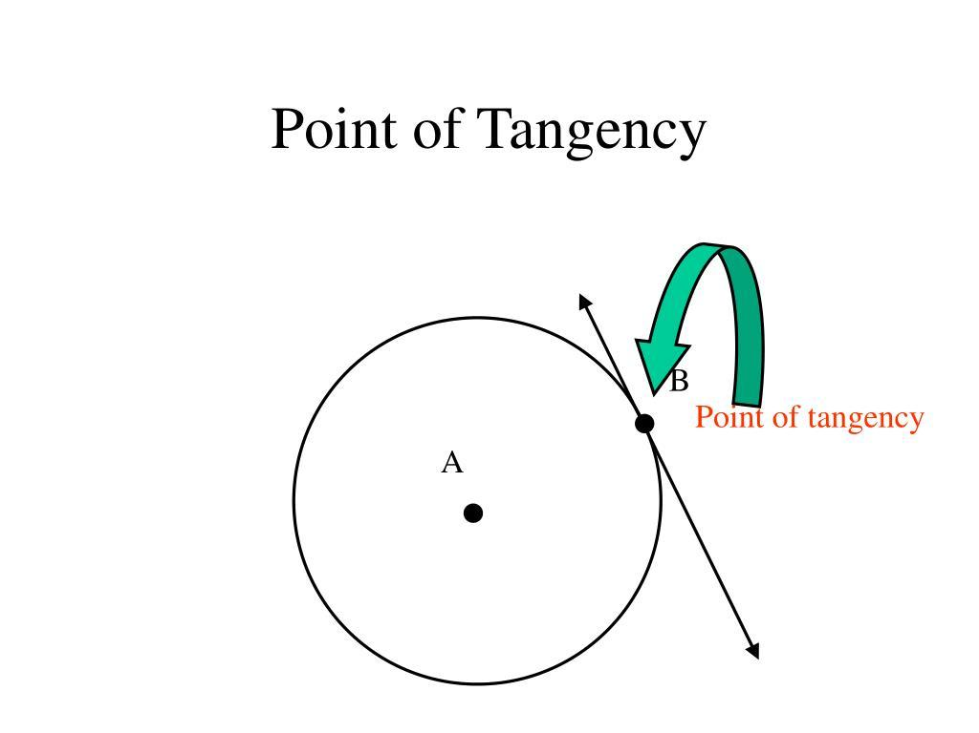
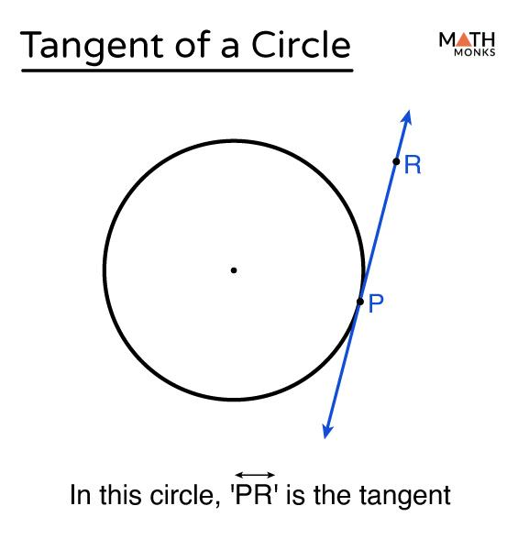
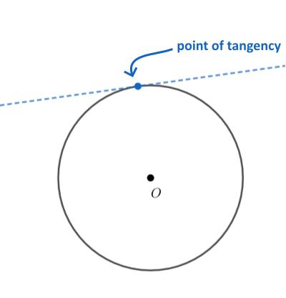
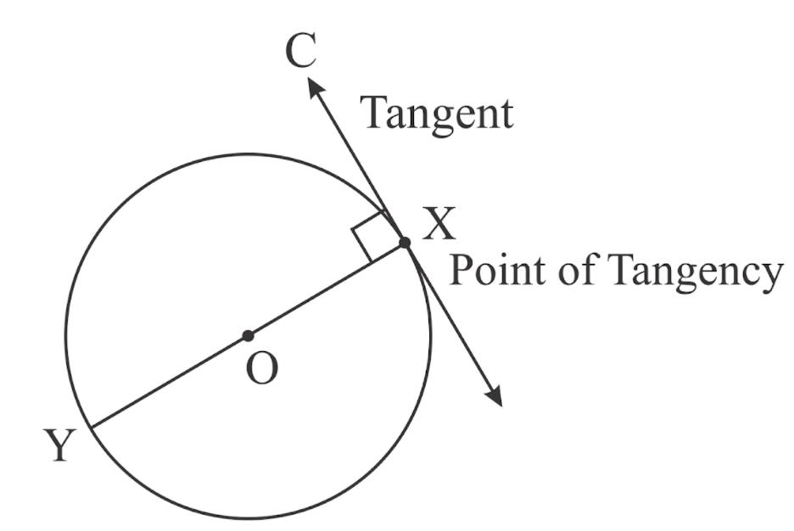
If line $l$is tangent to a circle with center $O$at $T$, then:
$$\boxed{l∩\text{circle}=\left\{T\right\}}$$

Fundamental Concept
# Source: AI Source: Provided by: [Data Path: Persons Table -> ID Column: 1, Name_En Column: Motasem Essam] -> From: [ChatGPT] on [7/25/2026]
A line and a circle can have three basic relationships:
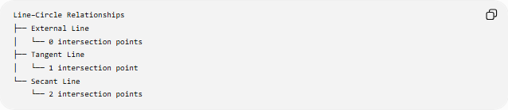
Line–Circle Relationships
├── External Line
│ └── 0 intersection points
├── Tangent Line
│ └── 1 intersection point
└── Secant Line
└── 2 intersection points
The tangent case is the boundary between an external line and a secant line.

Main Parts
# Source: AI Source: Provided by: [Data Path: Persons Table -> ID Column: 1, Name_En Column: Motasem Essam] -> From: [ChatGPT] on [7/25/2026]
For a circle with center $O$, tangent line $l$, and tangency point $T$:
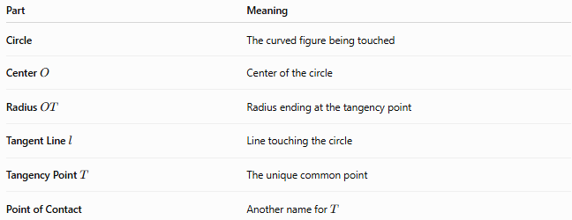
Part | Meaning
Circle | The curved figure being touched
Center $O$ | Center of the circle
Radius $OT$ | Radius ending at the tangency point
Tangent Line $l$ | Line touching the circle
Tangency Point $T$ | The unique common point
Point of Contact | Another name for $T$

Radius–Tangent Theorem
# Source: AI Source: Provided by: [Data Path: Persons Table -> ID Column: 1, Name_En Column: Motasem Essam] -> From: [ChatGPT] on [7/25/2026]
The most important property of line–circle tangency is:
The radius drawn to the point of tangency is perpendicular to the tangent line.
Therefore:
$$\boxed{OT⊥l}$$
and:
$$\boxed{∠OTL={90}^{∘}}$$
This property can also be used in reverse:
If a line through a point $T$on a circle is perpendicular to radius $OT$, then that line is tangent to the circle at $T$.

Distance from Center to Tangent
# Source: AI Source: Provided by: [Data Path: Persons Table -> ID Column: 1, Name_En Column: Motasem Essam] -> From: [ChatGPT] on [7/25/2026]
The perpendicular distance from the center $O$to the tangent line equals the radius.
$$\boxed{d\left(O , l\right)=r}$$
where:
- $d\left(O , l\right)$= perpendicular distance from $O$to line $l$
- $r$= radius
This gives a useful test for determining the relationship between a line and a circle.

Line–Circle Position Test
# Source: AI Source: Provided by: [Data Path: Persons Table -> ID Column: 1, Name_En Column: Motasem Essam] -> From: [ChatGPT] on [7/25/2026]
For a circle with radius $r$, let $d$be the perpendicular distance from its center to a line.

If d > r → External line
If d = r → Tangent line
If d < r → Secant line
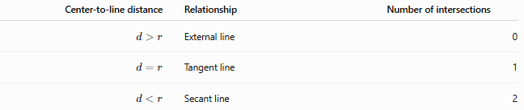
Center-to-line distance | Relationship | Number of intersections
$$d>r$$ | External line | 0
$$d=r$$ | Tangent line | 1
$$d<r$$ | Secant line | 2
Thus:
$$\boxed{d=r ⟺\text{ line is tangent to circle}}$$

Tangency Point
# Source: AI Source: Provided by: [Data Path: Persons Table -> ID Column: 1, Name_En Column: Motasem Essam] -> From: [ChatGPT] on [7/25/2026]
The point $T$is the only point common to the line and circle.
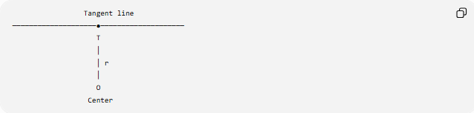
Tangent line
────────────────────●────────────────────
T
│
│ r
│
O
Center
The segment $OT$:
- is a radius;
- connects the center to the circle;
- ends at the tangency point;
- is perpendicular to the tangent.

Tangent Segment
# Source: AI Source: Provided by: [Data Path: Persons Table -> ID Column: 1, Name_En Column: Motasem Essam] -> From: [ChatGPT] on [7/25/2026]
If $P$is a point outside the circle and $T$is the tangency point, then $\overset{‾}{PT}$is a tangent segment.
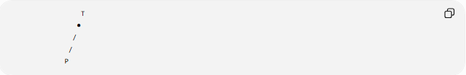
T
●
/
/
P
The segment touches the circle at $T$but does not pass through the interior of the circle.
If two tangent segments are drawn from the same external point $P$:
$$\boxed{PA=PB}$$

Two Tangents from an External Point
# Source: AI Source: Provided by: [Data Path: Persons Table -> ID Column: 1, Name_En Column: Motasem Essam] -> From: [ChatGPT] on [7/25/2026]
A point outside a circle can have two tangent lines to the circle.
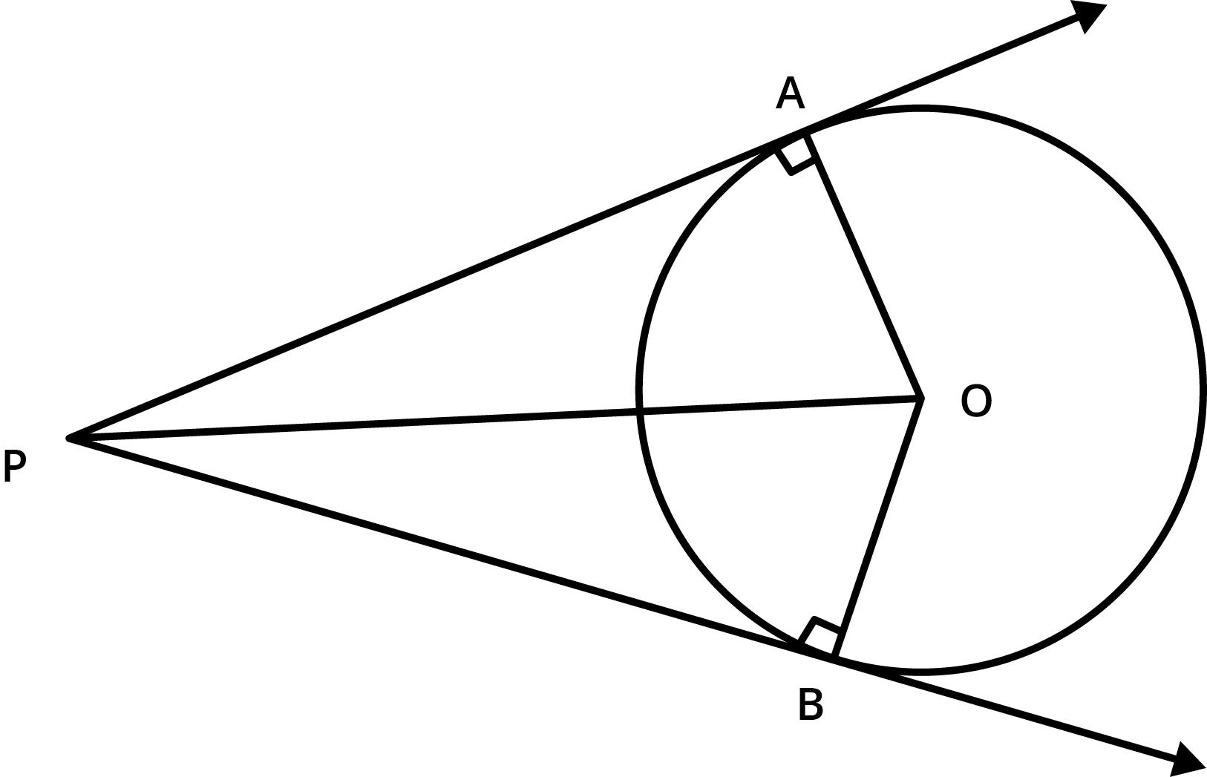
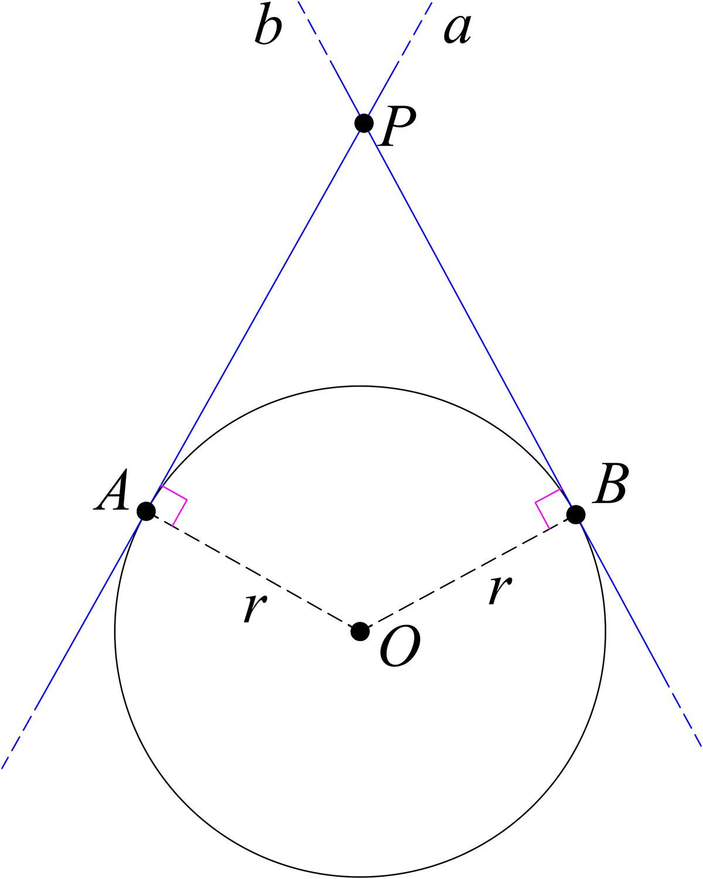
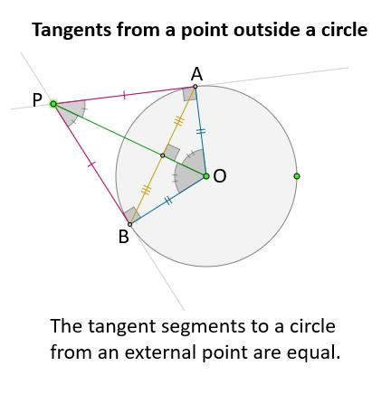
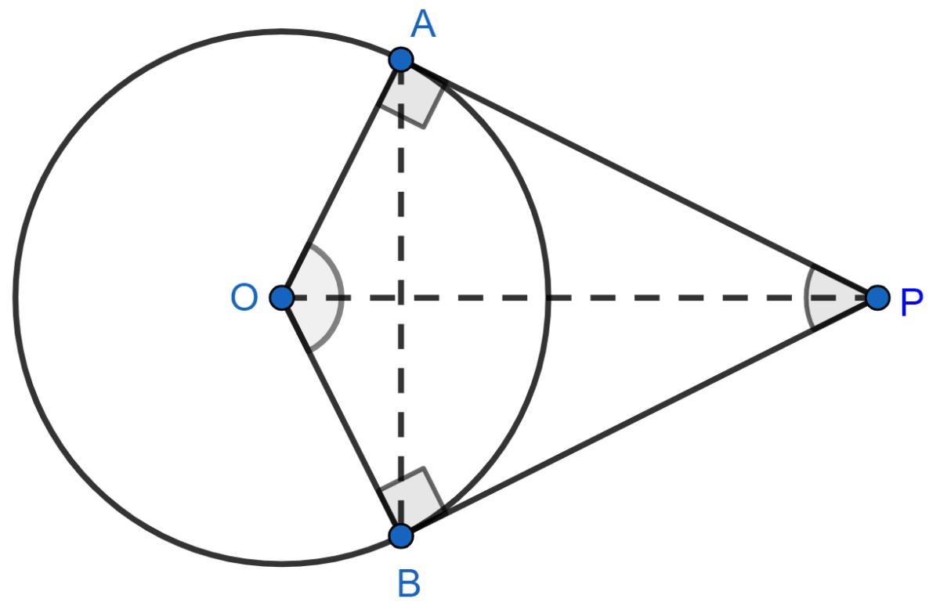
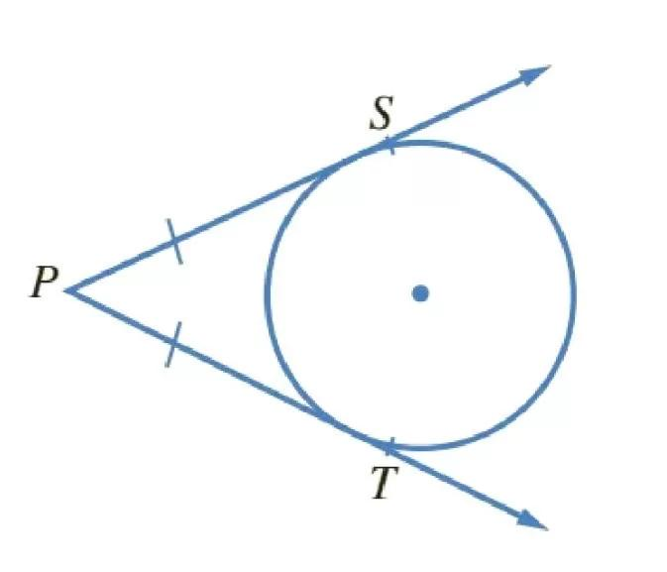
If $A$and $B$are the tangency points:
$$\boxed{PA=PB}$$
The radii are perpendicular to their respective tangent lines:
$$OA⊥PA \\ OB⊥PB$$

Tangent and Radius Form a Right Triangle
# Source: AI Source: Provided by: [Data Path: Persons Table -> ID Column: 1, Name_En Column: Motasem Essam] -> From: [ChatGPT] on [7/25/2026]
When an external point $P$is connected to the center $O$and tangency point $T$, triangle $POT$is a right triangle.
$$OT=r$$
and:
$$OT⊥PT$$
Therefore, by the Pythagorean theorem:
$$\boxed{OP^{2}=OT^{2}+PT^{2}}$$
Since $OT=r$:
$$\boxed{PT=\sqrt{OP^{2}-r^{2}}}$$

Coordinate Geometry
# Source: AI Source: Provided by: [Data Path: Persons Table -> ID Column: 1, Name_En Column: Motasem Essam] -> From: [ChatGPT] on [7/25/2026]
Consider the circle:
$${\left(x-h\right)}^{2}+{\left(y-k\right)}^{2}=r^{2}$$
and a line:
$$Ax+By+C=0$$
The perpendicular distance from the center $\left(h , k\right)$to the line is:
$$d=\frac{∣Ah+Bk+C∣}{\sqrt{A^{2}+B^{2}}}$$
The line is tangent exactly when:
$$\boxed{\frac{∣Ah+Bk+C∣}{\sqrt{A^{2}+B^{2}}}=r}$$

Tangent Line at a Known Point
# Source: AI Source: Provided by: [Data Path: Persons Table -> ID Column: 1, Name_En Column: Motasem Essam] -> From: [ChatGPT] on [7/25/2026]
For the circle:
$${\left(x-h\right)}^{2}+{\left(y-k\right)}^{2}=r^{2}$$
if $T\left(x_{1} , y_{1}\right)$lies on the circle, the tangent line at $T$is:
$$\boxed{\left(x_{1}-h\right)\left(x-x_{1}\right)+\left(y_{1}-k\right)\left(y-y_{1}\right)=0}$$
The radius $OT$is perpendicular to this line.

Special Case: Tangent to a Unit Circle
# Source: AI Source: Provided by: [Data Path: Persons Table -> ID Column: 1, Name_En Column: Motasem Essam] -> From: [ChatGPT] on [7/25/2026]
For a unit circle centered at the origin:
$$x^{2}+y^{2}=1$$
at a point:
$$T\left(x_{1} , y_{1}\right)$$
the tangent equation is:
$$\boxed{x_{1}x+y_{1}y=1}$$
provided:
$$x_{1}^{2}+y_{1}^{2}=1$$

Tangency vs. Secancy
# Source: AI Source: Provided by: [Data Path: Persons Table -> ID Column: 1, Name_En Column: Motasem Essam] -> From: [ChatGPT] on [7/25/2026]
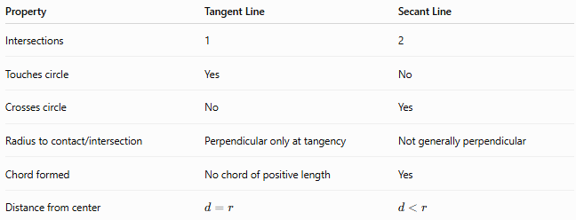
Property | Tangent Line | Secant Line
Intersections | 1 | 2
Touches circle | Yes | No
Crosses circle | No | Yes
Radius to contact/intersection | Perpendicular only at tangency | Not generally perpendicular
Chord formed | No chord of positive length | Yes
Distance from center | $$d=r$$ | $$d<r$$

Examples

Example 1 — Identifying a Tangent
# Source: AI Source: Provided by: [Data Path: Persons Table -> ID Column: 1, Name_En Column: Motasem Essam] -> From: [ChatGPT] on [7/25/2026]
A circle has radius:
$$r=7\text{ cm}$$
A line is $7$cm from the center.
Since:
$$d=r$$
the line is tangent to the circle.
Therefore, it has exactly one intersection point.

Example 2 — Finding Tangent Length
# Source: AI Source: Provided by: [Data Path: Persons Table -> ID Column: 1, Name_En Column: Motasem Essam] -> From: [ChatGPT] on [7/25/2026]
Suppose:
$$OP=13\text{ cm}$$
and:
$$r=5\text{ cm}$$
Then:
$$PT=\sqrt{{13}^{2}-5^{2}} \\ PT=\sqrt{169-25} \\ PT=\sqrt{144} \\ \boxed{PT=12\text{ cm}}$$

Important Properties
# Source: AI Source: Provided by: [Data Path: Persons Table -> ID Column: 1, Name_En Column: Motasem Essam] -> From: [ChatGPT] on [7/25/2026]
- A tangent line has exactly one common point with a circle.
- The common point is the tangency point.
- The radius to the tangency point is perpendicular to the tangent.
- The distance from the center to the tangent line equals the radius.
- A point inside a circle cannot have a tangent line to the circle.
- A point on a circle has exactly one tangent line.
- A point outside a circle can have two tangent lines.
- Tangent segments from the same external point are equal.
- A tangent line does not cross the interior of the circle.
- A tangent can be viewed as the limiting case between an external line and a secant.

Classification
# Source: AI Source: Provided by: [Data Path: Persons Table -> ID Column: 1, Name_En Column: Motasem Essam] -> From: [ChatGPT] on [7/25/2026]
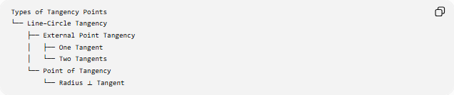
Types of Tangency Points
└── Line–Circle Tangency
├── External Point Tangency
│ ├── One Tangent
│ └── Two Tangents
└── Point of Tangency
└── Radius ⟂ Tangent
More precisely, Line–Circle Tangency itself is a type of tangency relationship, while the Tangency Point is the single common point produced by that relationship.

Key Formulas
# Source: AI Source: Provided by: [Data Path: Persons Table -> ID Column: 1, Name_En Column: Motasem Essam] -> From: [ChatGPT] on [7/25/2026]
Radius–Tangent
$$\boxed{OT⊥l}$$
Center-to-Line Distance
$$\boxed{d\left(O , l\right)=r}$$
Tangent Length
$$\boxed{PT=\sqrt{OP^{2}-r^{2}}}$$
Equal Tangent Segments
$$\boxed{PA=PB}$$
General Circle
$$\boxed{{\left(x-h\right)}^{2}+{\left(y-k\right)}^{2}=r^{2}}$$

Key Points
# Source: AI Source: Provided by: [Data Path: Persons Table -> ID Column: 1, Name_En Column: Motasem Essam] -> From: [ChatGPT] on [7/25/2026]
- Line–Circle Tangency occurs when a line touches a circle at exactly one point.
- The common point is the Tangency Point.
- The radius to the tangency point is always perpendicular to the tangent.
- The center-to-line distance equals the radius.
- An external point can have two tangent lines to a circle.
- Tangent segments from the same external point are equal.
- A tangent line has one intersection, while a secant has two.

